**QUOTATION ……………/………………….**

**FOR THE SUPPLY OF STORMBOX I SYSTEM**

**MADE OF INFILTRATION AND ATTENUATION BOXES**

1. TECHNICAL DESCRIPTION

The STORMBOX I system was designed to manage rainwater by its storage and subsequent use or gradual gravity-driven drainage into the soil. Rainwater is caught from the roofs of buildings and industrial facilities and is then directed through gutters, discharge pipes and sewage pipes to the inspection and/or collection chambers and driven to the filtering system STORMBOX I.

The drain boxes, the bottom plates, and the clips of STORMBOX I system are made of polypropylene (PP-B) through the injection molding method. The boxes are joined by means of fixing elements – clips at the designated places.

|  |  |
| --- | --- |
| **Essential technical data** | |
| Material | Polypropylene (РР-В) |
| Dimensions (length/width/height) | 1200 х 600 х 300 mm |
| Number of openings | 8 |
| Diameter of openings | 110, 125, 160, 200 mm |
| Gross capacity | 216 dm³ |
| Net capacity | 95.5 % |
| Water collection capacity | 206 dm³ |
| Bottom plate | 1200 х 600 х 20 mm |
| Color | Green (RAL 6024) |

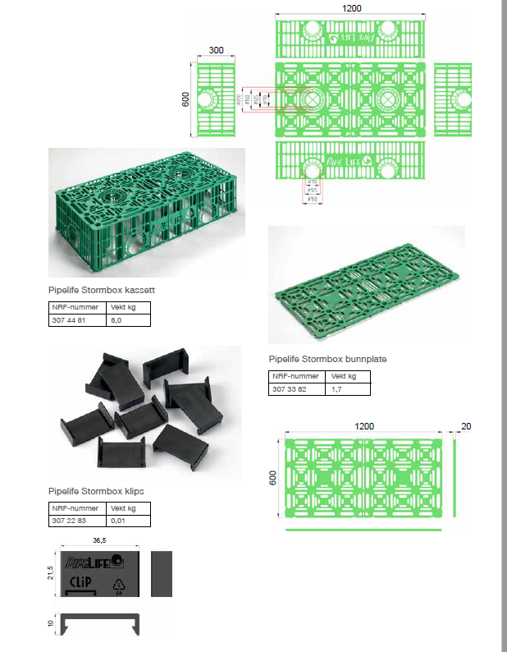

1. **The advantages of boxes STORMBOX I**

* High durability;
* Good weight and durability ratio;
* High water infiltration capacity – 206 dm³;
* High water storage capacity – 95.5%;
* Large mean active surface area of inlets (greater than 50%)
* Possibility to connect pipes with DN 110, 125, 160 and 200 mm
* 8 openings for inspection on the lateral sides and the top plate (6 openings 110-160 mm on the lateral sides and 2 openings on the top plate 110-200 mm)
* Possibility for cutting in two and building modular structures;
* Possibility for building dynamic structures (like bricks);
* Low weight, only 8 kg;
* Easy installation;
* The bottom plate is to be used only for the bottom layer;
* Lower investment costs for the tank by approx. 20% as compared to the boxes with bottom plate.

1. **Parameters for installation in areas with intensive motor vehicle traffic load**

* Min. layer thickness above the drainage boxes: 0.8 m;
* Compaction of the soil surrounding the boxes: minimum 95% according to the modified Proctor test;
* Max. number of boxes layers in one module: 6 for heavy truck traffic load (max. height of the boxes 1.82 m), 10 for light-weight motor vehicle traffic load (max. height of the boxes 3 m);
* Deep laying of the boxes’ bottom plates; up to 4.5 m and in case of deeper laying, please contact Pipelife to do the necessary calculations for verification of the soil conditions and the anticipated traffic load.

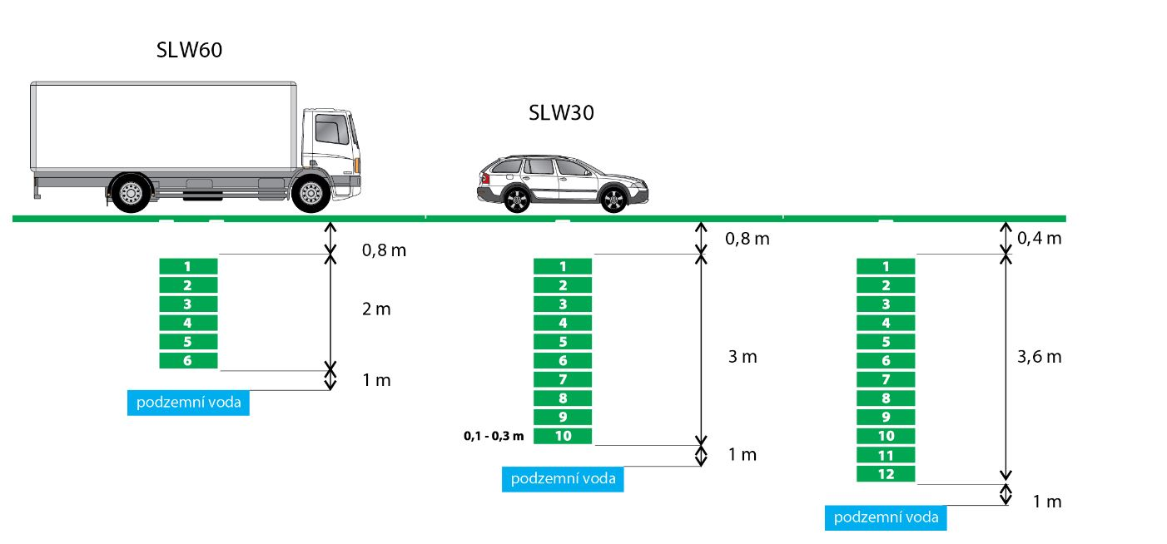

Maximum strengths short-term:

* 500 кN/m² at vertical loading;
* 85 кN/m² at lateral loading.

Maximum strengths long-term:

* 100 кN/m² at vertical loading;
* 20 кN/m² at lateral loading.

1. **Order and sequence of installation works for the tank functioning as rainwater discharger.**

* **Infiltration of rainwater** — water is collected in the Stormbox I boxes during rainfalls and infiltrates into the soil over a certain time interval 6 - 72 hours, according to ATV-DVWK-A-139 after the rain stops. For that purpose, the box system is wrapped in non-woven geotextile to prevent the filling up of boxes with particles from the surrounding soil.

Therefore, we offer:

* Stormbox boxes, according to DWA-A 138
* Geotextile, non-woven, according to  [EN 13252](http://www.bds-bg.org/standard/info.php?standard_id=19363)

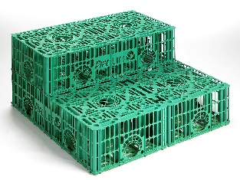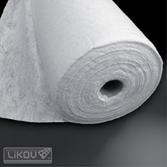

1. Digging a pit whose min. width will be 40-50 cm larger than the size of the boxes module.
2. Removing the protruding stones from the bottom of the pit and backfilling it with min. 10-15 cm thick layer of gravel with particle size 8-16, 12-24 (30) mm or sand layer but using sand with coarser particles. The backfill is to be flatted and evened.
3. Removing the open work fences from the points of joining the pipes 160 mm, for ventilation (110-200 mm) or inspection. Attention: All open work fences must be removed from the points intended for inspection through a manhole or through a vertical pipe.
4. Covering the bottom with geotextile by providing some 15-50 cm in excess and leaving the edges free so that the boxes could be wrapped from all sides before backfilling with soil.
5. Arranging the bottom plates of the boxes on the geotextile and then the boxes proper and joined that will be by the click system. The points of joining are marked with the sign “CLIP”
6. Wrapping the boxes very well with geotextile by providing some 15-50 cm in excess. Cutting the geotextile in eight at the inlet. Then inserting about 20 cm of the inlet pipe so that the cup would be protruding from the inlet. Attention: Ensure that the geotextile is closely adhering to the pipe cup.
7. Connecting the boxes to the inlet pipes 160 mm with stiffness SN 4 kN/m² (for lawns) or SN 8 kN/m² for the settlement chamber and for inspection chamber PRO 400, PRO 630 or for the inlet PRO 800, PRO 1000. Calculating the required number of outlet pipes from the chamber in consideration of the amount of inlet flow rate.
8. Deaerating the opposite end of the boxes module using sewer pipes PVC-U 110 mm (160 or 200 mm) that should be connected to the pipe cup fitted to the top plate opening of the box, and drawing out the pipe ending with a vent by some 50 cm above the area level. That same pipe can be used for inspection purposes.
9. Backfilling the lateral areas around the boxes with 15-30 cm layer of gravel with particle size 8-16, 12-24 (30) mm or coarser sand. Flattening and compacting the padding layer. Calculating the extent of soil compaction in consideration of the anticipated traffic load. Backfilling the boxes with a 10-15 cm thick layer of sand (no stones or other sharp items that could damage the geotextile or the boxes) and compacting.
10. **Sequence of the installation works for the tank functioning as a rainwater collector.**

* **Retention/storage of rainwater** — water is collected in the Stormbox I boxes during rainfalls and discharged from the system by means of a controlled drain flow to a suitable receiver. For that purpose, the system of boxes is wrapped in geomembrane of selected material (PP, PE, or PVC) to create impermeability. Woven geotextile is used to protect the geomembrane on the boxes surfaces and also against coarse particles that could harm the surrounding soil layer.

Therefore, we offer:

* Stormbox boxes, according to DWA-A 138
* Geotextile-woven, according to  [EN 13252](http://www.bds-bg.org/standard/info.php?standard_id=19363)
* Geomembrane, according to  [EN 139671](http://www.bds-bg.org/standard/info.php?standard_id=19363)

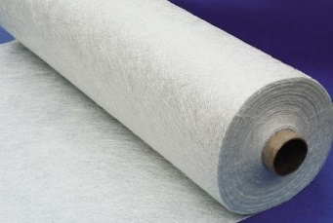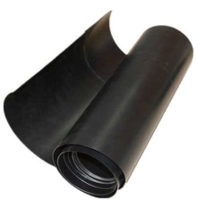

1. Digging a pit whose min. width will be 40-50 cm larger than the size of the boxes module.
2. Removing the protruding stones from the bottom of the pit and backfilling it with min. 10-15cm thick base layer of sand (no stones). The backfill is to be flatted and evened.
3. Removing the open work fences from the points of joining the pipes 160 mm, for ventilation (110-200 mm) or inspection. Attention: All open work fences must be removed from the points intended for inspection through a manhole or through a vertical pipe.
4. Covering the bottom with geotextile of at least 300 g/m² thickness, leaving 15-50 cm in excess, and then PVC geomembrane (water-insulating foil) at least 1.5 mm thick. The foil (sized 2 m х 20 m) is laid by overlapping 10 cm of both edges, and then heated. Then a second layer of geotextile is laid on the bottom, leaving some 15 cm – 50 cm for overlapping and leaving the necessary excessive amount by the sides so that the boxes could be wrapped from all sides. This geotextile shall protect the foil from damages.
5. Arranging the bottom plates of the boxes on the geomembrane and then the boxes proper and joined that will be by the click system. The points of joining are marked with the sign “CLIP”.
6. Wrapping the boxes very well with the geomembrane by providing some 15-50 cm for overlapping the edges.
7. Wrapping the boxes with the foil by heating. Making holes in the boxes inlets for the inlet pipes or for ventilation and inspection. Then preparing PVC-U pipes with total length of 50 cm (without the cup). Fitting the prepared pipe ends with the sealing ring, then making the foil collars adhere to the pipes by heating. Driving about 20 cm of the pipes into the box openings, then heating the foil collars around the pipes. Putting a metal foil on the collar as a ring and tightening the bolts. The ring can be further strengthened by fitting the foil and making it adhere by heating.

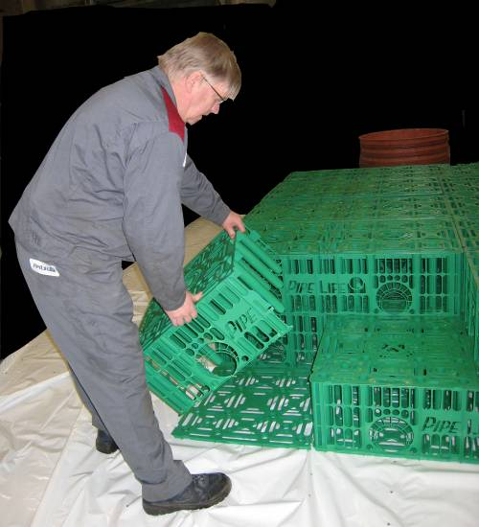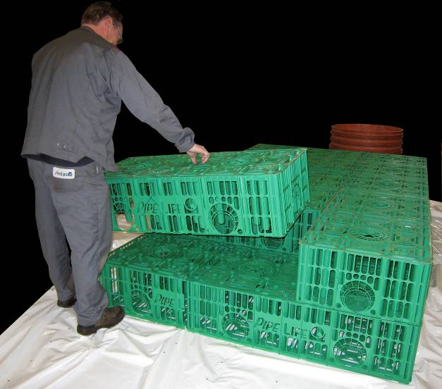

*STORMBOX’s can be halved and added to the application.*

1. Making a vent on the other end of the block set using sewer pipes of PVC-U 110 mm (160 or 200 mm) that should be connected to the pipe cup fitted to the top plate opening of the block and drawing out the pipe ending with a vent by some 50 cm above the area level. To ensure the possibility for inspection, as well as for cleaning the tank, the pipes should be equipped with tips made of PVC-U 200 mm pipes ending with a telescope Т20 (40t), ТО5М (5t) or a cone with class А15 concrete cover.
2. Backfilling the lateral sides with a 15-30 cm thick layer of sorted sand, free of any stones and other sharp items. Flattening and compacting the padding layer. Calculating the extent of soil compaction in consideration of the anticipated traffic load.
3. Backfilling the boxes with a 10-15 cm thick layer of sorted sand, free of any stones and other sharp items, flattening and evening that layer. Special measures should be taken to prevent crumbling of the pit sides, or foil coming off or falling of stones and other sharp items. Additional measures to protect the foil by covering it with geotextile is advisable.
4. **Pipelife Bulgaria is not a performer of construction and installation works and cannot supply the aggregates necessary for installing the structure!**
5. **Options for pipe connections in the system**

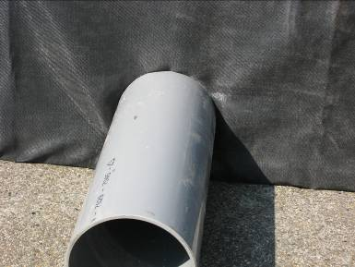

1. **Possibility for CCTV inspection and monitoring**

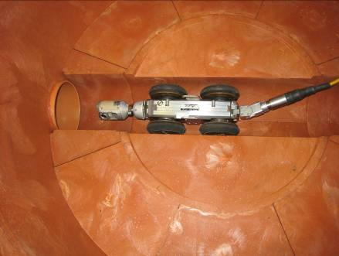



1. **What to do and what not to do**

|  |  |
| --- | --- |
| GoodMCj04413100000[1] | WrongMCj03912000000[1] |
| Flat even surface | Inclined surface above the boxes |
| Only light-weight machinery should be allowed to move on the surface at the time of installation | No cranes or other heavy machinery should be allowed to move on the boxes before putting the final layer – the sidewalks. |