**QUOTATION ……………/………………….**

**FOR THE SUPPLY OF STORMBOX II SYSTEM**

**MADE OF INFILTRATION AND ATTENUATION BOXES**

1. TECHNICAL DESCRIPTION

The STORMBOX II system was designed to manage rainwater by its storage and subsequent use or gradual gravity-driven drainage into the soil. Rainwater is caught from the roofs of buildings and industrial facilities and is then directed through gutters, discharge pipes and sewage pipes to the inspection and/or collection chambers and driven to the filtering system STORMBOX II.

1. The drain boxes, the bottom plates, and the clips of STORMBOX II system are made of polypropylene (PP-B) through the injection molding method. **Method of joining the drain boxes:** Patented method for joining the boxes without clips – “herringbone” type of connection. The bottom plate is used only for the bottom layer without the use of clips (the “press” method**)**.
2. **Essential technical data**

**Technical parameters**

|  |  |
| --- | --- |
| Material: | Polypropylene PP-B |
| Dimensions (length х width х height): | 1200 x 600 x 600 mm |
| Number of tunnels: | 2 on the long side, 1 on the short side |
| Gross capacity: | 432 dm3 |
| Net capacity: | 95.5% |
| Water collection capacity: | 412.6 dm3 |

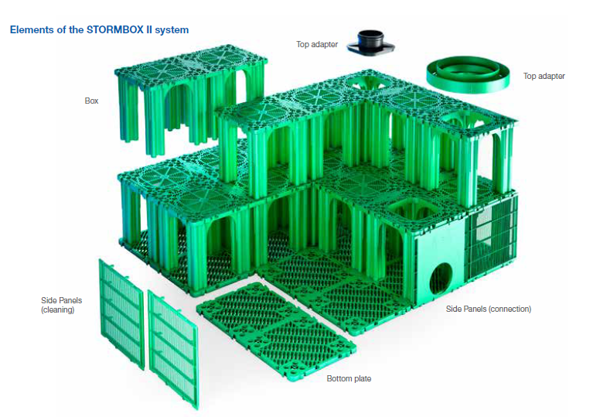

1. **Advantages of the boxes STORMBOX II**

* One of the most durable boxes available on the market, offering more than 50-years of service life
* Durability at max. vertical load exceeding 700 kN/m2
* Modular structure for easy and quick installation
* Patented and innovative design of the lateral and bottom sides to prevent any damages on the geotextile during high-pressure cleaning, the direction of cleaning is marked on the bottom plate
* Three horizontal tunnels 295 mm wide and 500 mm high used for cleaning and inspection with a camera for video-monitoring
* The block structure is more open, which helps improve infiltration
* Possibility for variation of structure (like bricks)
* Two vertical openings with max. width of the opening on the top plate 400 mm
* Twice as quicker installation of the boxes
* Possibility for both horizontal and vertical cleaning and inspection
* Connection of pipes with diameter 160-400 mm to the block
* Innovative PР adapter that can be fitted on the top side to allow for inspection using two-layered pipes PP DN/OD 630 and 400 mm SN 8, SN 4
* High net water capacity - 412.6 l, net capacity coefficient 95,5%
* Patented method of joining the boxes without clips
* The bottom plate is used only for the bottom layer without the use of clips (the “press” method)
* Thicker and stiffer bottom plate
* Possibility to cut the boxes in two and variation in the arrangement of structure
* Suitable for delaying the discharge or storage of water
* Complete delivery of all necessary items, i.е. geotextile and adapters

1. **Parameters for installation in different types of areas**

* **Depth of laying in areas with medium to heavy traffic:** min.depth 0.8 m, max.depth 4.15 m
* **Depth of laying in lawn areas:** min.depth 0.4 m, max.depth 4.15 m
* **Short-term strength at vertical loading of the system:** ≥ 600 kN/m2 (EN 17150:2019)
* **Short-term strength at horizontal loading of the system:** ≥ 100 kN/m2 (EN 17150:2019)
* **Long-term strength at vertical loading of the system (for 50 years):** 234.6 kN/m2 (EN 17151:2019)
* **Long-term strength at horizontal/lateral loading of the system (for 50 years):** 28.8 kN/m2 (EN 17151:2019)

1. **Sequence of performing the installation works**

Installation

To ensure the proper and durable function of the STORMBOX II system follow the instructions detailed below:

* + The installation of the whole system must be carried out in accordance with the instructions and local regulations.
  + The bottom of the pit must be made flat and even, without any bumps or holes. A 10-15 cm thick sand padding layer should be made and then compacted.
    - For the building of the drainage system for infiltration, the level of underground water must be at least 1.0 m lower than the bottom of the boxes.

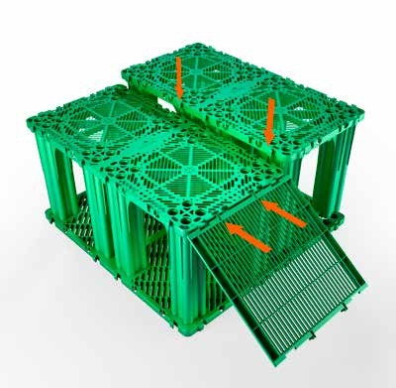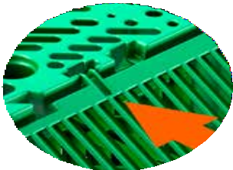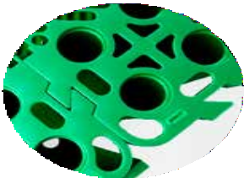

Easy joining of the boxes by “herringbone” type of connection

Lateral sides are mounted on hinges by sliding

* + - Use suitable geotextile in terms of the material it is made. The use of high-density woven geotextile is advisable.
    - Backfill the lateral areas of the boxes with fine gravel.
    - Backfill the wheeled vehicles traffic area with at least 80 cm thick layer of compacted earth that should be top covered with asphalt or concrete.
    - When applying geotextile or foil (in case of retention tanks), an overlap of 15-50 cm must be made.
    - Place the bottom plates on the geotextile by joining them together using the “dovetail” type of connection
    - Place the vertical columns in the bottom

openings.

* + - Mount the lateral panels only along the

external walls of the tank at the designated points.

* + - Remember to position properly the connecting panels.
    - Wrap the entire tank with geotextile and foil (if it is a retention tank).
    - Mount the adapters on the top block as specified in the relevant design requirements.
* **Diameters of the inlets to the drainage boxes for filing and for inspection purposes:** For connection through the lateral sides 160, 200, 250, 315 и 400 mm. for smooth-wall or ribbed-wall pipes of PE, PP or PVC!
* **Adapters for top connection to the system, suitable for sewer pipes with diameters:** For connection through the top side OD 400, OD 200, for smooth-wall or ribbed-wall pipes of PE, PP or PVC!

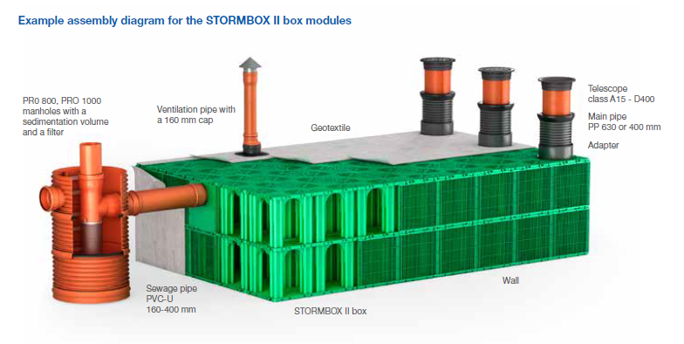

1. **Pipelife Bulgaria is not a performer of construction and installation works and cannot supply the aggregates necessary for installing the structure!**
2. **Possibility for CCTV inspection and monitoring**

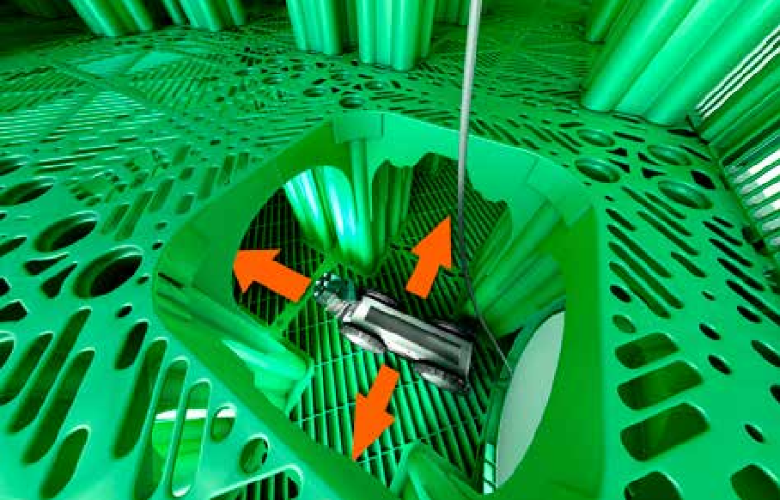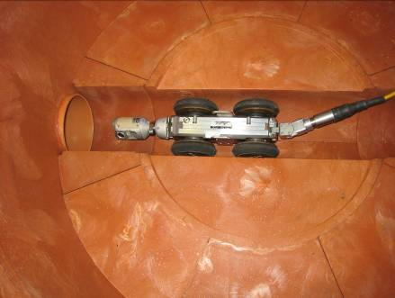



1. **What to do and what not to do**

|  |  |
| --- | --- |
| GoodMCj04413100000[1] | WrongMCj03912000000[1] |
| Flat even surface | Inclined surface above the boxes |
| Only light-weight machinery should be allowed to move on the surface at the time of installation | No cranes or other heavy machinery should be allowed to move on the boxes before putting the final layer – the sidewalks |