Sewer pipes made of spirally-wound polyethylene – Pragnum type
      - Product definition and manufacturing standard
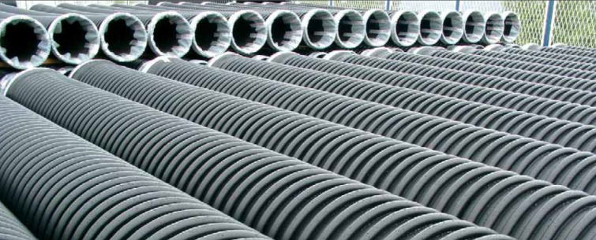
Similar to the corrugated sewer pipes, the spirally-wound polyethylene pipes have a structured wall consisting of smooth internal surface ensuring good hydraulic conductivity and ribbed external surface ensuring the required pipe strength, which is expressed as class of ring stiffness – SN. Such structure makes it possible to lower the consumption of input material per linear meter and accordingly to lower the pipe weight as compared to compact pipes made of the same material, provided the cross stiffness of the pipe ring stays the same. To put it short, the same product strength may be achieved by using less material and better intelligent design for the pipe structure.
The main production standards are БДС EN 13476-3 and DIN16961.
- Scope of application
The spirally-wound polyethylene pipes with electrical fusion welded sockets are mainly used for the building of large sewerage collectors with diameters starting from DN1000 to DN3000 which are applied in infrastructure sewerage systems, such as pipe connection lines between the facilities in the wastewater treatment plants (WWTP), wastewater collectors for the WWTP, cross river inverted siphons, deep sea water discharges, relining of existing sewer pipes.
- Material, marking and production process
The main material used for the production of spirally-wound polyethylene pipes is polyethylene 100 (PE100), and polypropylene block polymer (PP-B) is used for complementary reinforcement of the ribs, the application of each material is shown in the figure below:
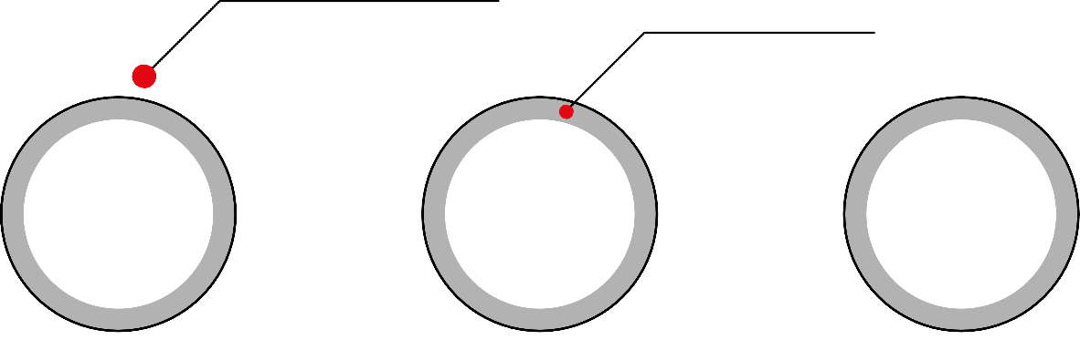
Ribbing layer, setting the pipe
stiffness.
Material PE100
(polyethylene 100).
Additional layer
reinforcing the ribs.
Material PP-B.
(polypropylene
block polymer).

Main layer, setting the shape of the pipe and the hydraulic capacity.
Material PE100. (polyethylene 100).

The most important specification of thermoplastic materials such as polyethylene is the so called melt flow index (liquefaction of thermoplastic materials). Based on the parameters of melt flow index, the manufacturer would know what kind of material he has available and what settings to program in the pipe producing machinery.
In the case of using primary raw material intended for the production of exactly that specific type of product – pipes, manholes and fittings made of spirally-wound polyethylene – this would be a warranty that the end product would meet the requirements of production standards – БДС EN 13476-3 and DIN 16961. When the raw material is a recycled one obtained from the recycling of products having no common characteristics with pipes, manholes and fittings of the respective plastic material, then the liquefaction of this recycled material would not be homogenous, therefore the quality of end product cannot be warranted because the product would not have uniform physical and mechanical properties and structure.
The pipe marking should provide basic information about the product such as diameter, length, ring stiffness, date of production, manufacturer, and trademark.
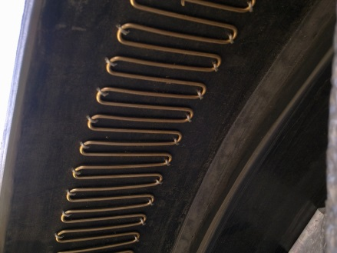
Pipes are manufactured by extrusion process where a compact or multi-layered profile is being wound around the pipe body at certain defined pitch.
Pipes are then joined using socket type joint which are equipped with integrated wire for electrical fusion welding. Such electrical fusion welding is performed in accordance with DVS 2207. This method of pipe joining improves the connection strength and totally prevents the loss of water tightness. It also allows the use of shorter socket for diameters larger than DN/ID1000 and more efficient longitudinal use of the pipes.

- Product list
DN  [mm] | DN/ID  [mm] |  | DN  [mm] | DN/ID  [mm]
700 | 700 |  | 1600 | 1600
900 | 900 |  | 1800 | 1800
1100 | 1100 |  | 2000 | 2000
1200 | 1200 |  | 2200 | 2200
1300 | 1300 |  | 2500 | 2500
1400 | 1400 |  | 2800 | 2800
1500 | 1500 |  | 3000 | 3000
Depending on the winding pitch and the profile geometry, pipes of any desired stiffness ranging from 4 kN/m² to 32 kN/m² may be produced.
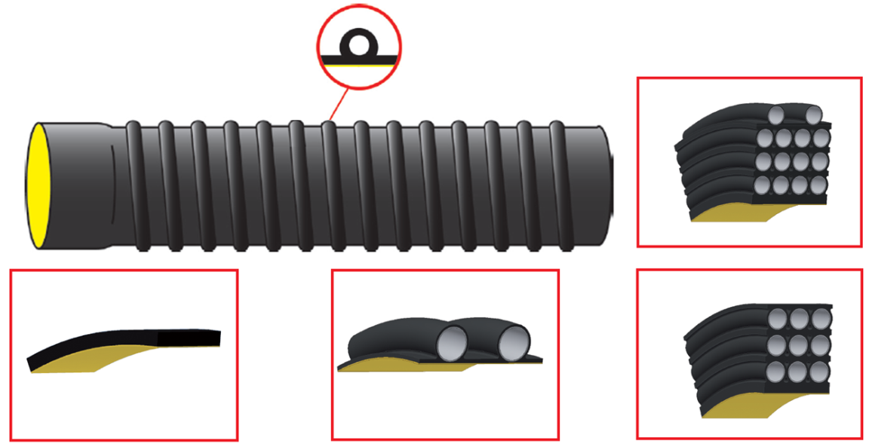
It is possible to manufacture pipes of non-standard stiffness, for example SN 7 kN/m2, nevertheless the class of stiffness must be proven to be stiff enough for the specific field conditions based on preliminary statistic calculations. This way the investor will save on cost, especially for diameters larger than DN/ID1000 as compared to the manufacture of pipes with standard stiffness SN8.
- Testing (core tests)
Cross ring stiffness is tested in accordance with DIN 16961 and БДС EN ISO 9969. This test guarantees the basic strength of the pipe at resistance to earth load pressure.
Ring flexibility is tested in accordance with БДС EN ISO 13968:2008. It guarantees the pipe strength at dynamic pressure from loads and unloads, backfilling and compacting, and traffic, and indicates its capacity for elastic deflection without being destroyed or plasticized, as well as its capability to resume initial shape. The result of this test is also indicative of the pipe impact resistance. The spirally-wound polyethylene pipes have 30% ring flexibility which makes it compliant with the standard requirements.

External impact resistance is tested in accordance with БДС EN 744, БДС EN 1411, БДС EN 12061
The testing of sample pieces taken from pipes delivered to the installation site for three major criteria can provide a realistic picture of pipe quality and possible prevent their installation if they are found not compliant with the applicable requirements. This way some future expenditure for replacing bad quality and defective pipes may be saved. Such tests will make it clear which manufacturer insists on quality and good name, by laying emphasis on strict production control and the use of top quality certified raw material, and which manufacturer is only after economic profit to the expense of quality and security, by neglecting production control and by putting into production some low quality, recycled and uncertified raw material.
The quality and integrity of welds is tested in accordance with DVS 2207.
- Requirements for installation
A major factor for ensuring quality installation and construction of infrastructure sewerage is the choice of soil to be used for backfilling and their compacting density. Over the years it has been well proven that the use of crushed stone ballast is suitable and efficient for obtaining maximum compacting density of backfill with minimum input resources. The spirally-wound polyethylene pipes may be directly backfilled with crushed stone ballast and it is advisable that the backfill used to form the under pipe padding should have maximum grain size up to 15 mm, the backfill in the area around the pipe that may reach max. 30 cm above the pipe crown should have maximum grain size up to 30 mm and the backfill in the area above the pipe reaching up to the roadbed should have maximum grain size up to 60 mm. The advisable minimum compacting density for all areas of backfill is 95% according to Proctor.
- Comparison to alternative products
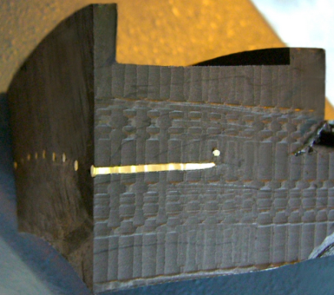
Practically, the joint between two pipes is fully monolithic and after welding the pipes form one whole unbroken piping system offering all consequential advantages for the system security and water tightness as compared to piping systems with socket type connection and rubber sealing, especially for diameters larger than DN/ID1000.

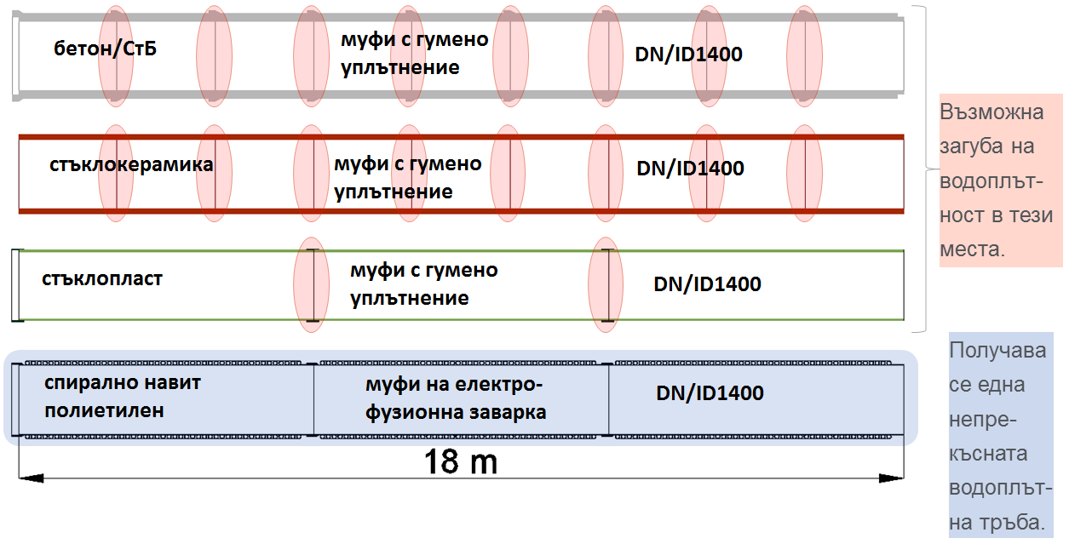
Concrete/reinforced concrete pipes | rubber sealed sockets | Possible loss of water tightness in the indicated points
Glazed ceramic pipes | rubber sealed sockets
Fiberglass pipes | rubber sealed sockets
Spirally-wound pipes | electrical fusion welded sockets | Uninterrupted water tightness of the pipe

pipe 6 m defection 300 mm angular deflection 3®
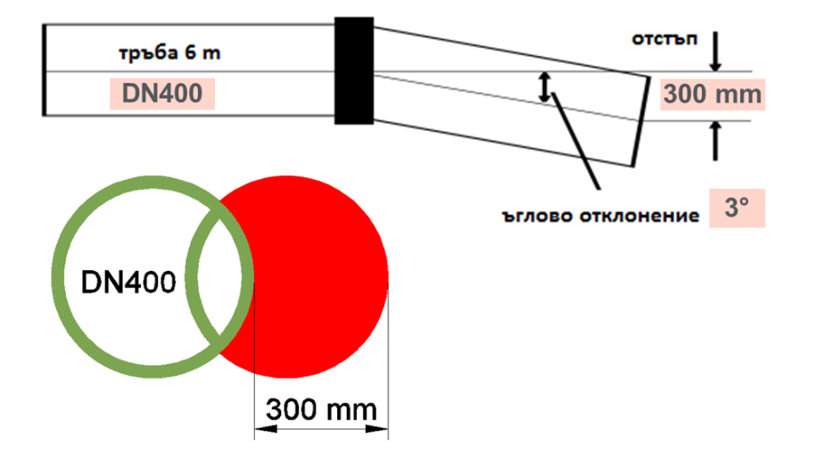
The joints mades by electrical fusion welding are very important for ensuring system security, especially for diameters greater than DN/ID1000 because the admissible margin of long axis deflection in the installation of pipes with socket type connection and rubber sealing lowers as an exponential function.
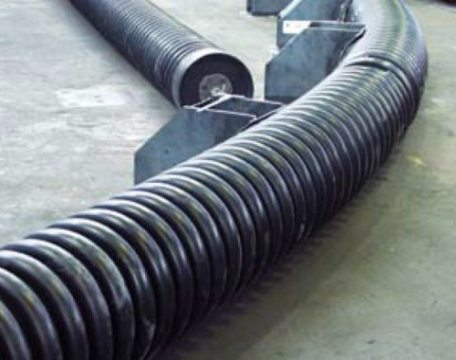
Assuming that the admissible angular deflection for pipes with diameter DN400 is 3 degrees, which for a 6 m long pipe will produce 300 mm deflection from the long axis of installation, then for pipes with diameter greater than DN1000 the admissible margin will be 0.5 degrees, which for a 6 m long pipe will produce 50 mm deflection from the long axis of installation.
At the same time the margin of deflection for spirally-wound polyethylene pipes is based on the rule that after welding all joints can be bended in relation to the long axis at bending curve radius R = 30 DN, which for pipes with diameter DN2400 will produce 240 mm deflection from the long axis of installation. This is several times bigger than the admissible margin of 50 mm for fiberglass pipes DN2400.
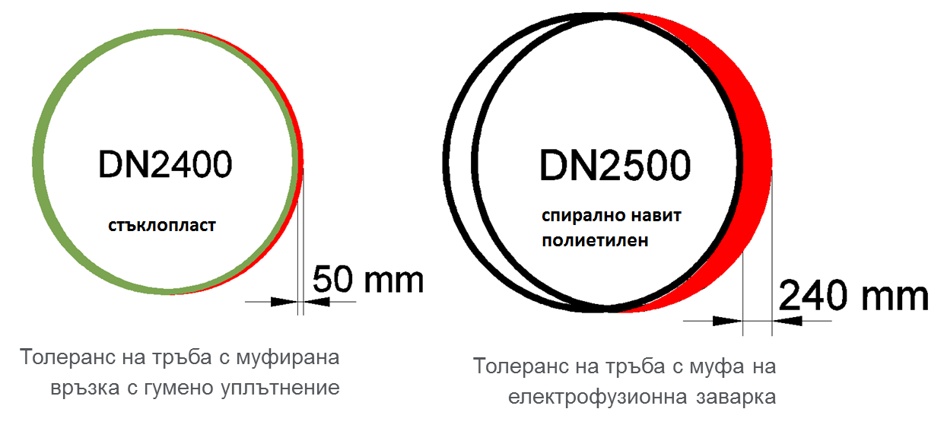
Fiberglass Spirally-wound polyethylene
admissible margin of deflection admissible margin of deflection
for a pipe with rubber sealed socket for a pipe with electrical fusion welded socket

The greater admissible margin of angular deflection in combination with the welded joints renders spirally-wound polyethylene pipes into the most secure solution for collectors with diameters greater than DN/ID1000, both in terms of their installation and in terms of their operation later on and possible extreme conditions caused by movement of earth layers due to sagging soil, rising soil or earthquakes.
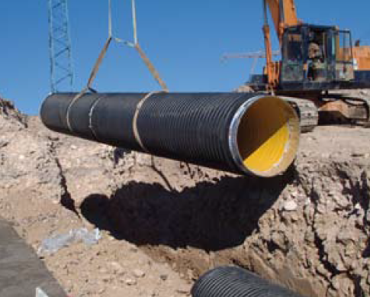
The designed electrical fusion welding provides the possibility for coupling in advance in the factory of two 6 m long pipes and to deliver and install them on the site as 12 m long pipes.
In addition to the spirally-wound polyethylene pipes, the same technology and the same material are used to produce lateral polyethylene manholes and fittings of large diameters – reducers, elbows, tees. Manholes and fittings and pipes as well can also be interconnected by means of electrical fusion welding. This way the entire system of elements will be completed with guaranteed absolute water tightness and strength of joints.
Flexible pipes such as spirally-wound polyethylene pipes would deflect after backfilling and compacting, i.e. their cross section gets deformed, which causes the soil load above the pipe to be redistributed so as part of it to be taken up by the backfill that is on the sides along the pipe. This way, the load applied on the pipe would be reduced and its long-term operation would be facilitated.
With regard to the water tightness of socket type connection the admissible deflection is:
- 6% for spirally-wound polyethylene pipes
- 3% for fiberglass pipes
Practically this means that one spirally-wound polyethylene pipe with standard stiffness of SN8 can be compared to a fiberglass pipe SN10 provided the conditions of installation stay the same. Needless to say, when the deflection requirements for the pipe are still stricter than 6%, spirally-wound polyethylene pipes can be offered at higher than the standard class of stiffness such as SN10, SN12, SN16, SN32 or at sufficiently high non-standard stiffness.
Hard pipes such as concrete or vitrified ceramic pipes practically do not deflect at all. Due to the fact that they are harder than the backfill, the backfill becomes more compact in the zones surrounding the pipe laterally than in the zone above the pipe, as a result of which additional weight is laid on the pipe itself.
Subjected to the pressure of unexpected overload, good quality flexible pipes made of spirally-wound polyethylene can sustain extreme deflection of 30% without destruction of their structural integrity. By deforming their cross section such pipes would transmit the load to the soil where as hard pipes would bear the whole weight of such unexpected overload, which may cause cracks and lead to destruction of their structural integrity.
The main purpose of sewer pipes is to conduct wastewater for as long time as possible at minimal maintenance cost. The main criteria here are hydraulic roughness, abrasion resistance, chemical resistance, high temperature resistance.
Absolute hydraulic roughness according to Colebrook-White:
- spirally-wound polyethylene pipes – 0.015 mm
- fiberglass pipes – 0.016 mm
- vitrified ceramic pipes – 0.035 mm
- concrete (reinforced concrete) pipes – 1.00 mm
Spirally-wound polyethylene pipe have time and again proven their abrasion resistance by passing successfully the relevant tests according to Darmstadt – Kirschmer method.
Wearing out the internal layer of pipe wall:
- spirally-wound polyethylene pipes 0.1 mm - after 130 000 test cycles
- fiberglass pipes 0.2 mm - after 100 000 test cycles
- vitrified ceramic pipes 0.1 mm - after 100 000 test cycles
Chemical resistance of the different pipes intended for infrastructure sewerage system:
- spirally-wound polyethylene pipes pH=2 ÷ pH=12
- fiberglass pipes pH=1 ÷ pH=10
- vitrified ceramic pipes pH=0 ÷ pH=14.
Practically, spirally-wound polyethylene pipes are almost identical with fiberglass and vitrified ceramic pipes in terms of chemical resistance. Taking into account also the fact that the usual values for wastewater collected from populated areas are pH=6.5 ÷ pH=7.5, it becomes clear that spirally-wound polyethylene pipes are fully resistant to the chemical impact of urban wastewater and quite a wide range of industrial wastewater.
The high temperature resistance of sewer pipes is essential for sections of the urban sewerage system, which are located near factories letting out high temperature heated wastewater, and also for the local sewerage system of such industrial enterprises. It is just as well important that pipes located near residential buildings or public catering facilities to be resistant to high temperature heated wastewater.
Among the modern methods for washing out/removal of deposits from the walls of sewer pipes, the method employing reactive jet (jetting) is widely used by the operators of sewerage systems. There are two basic methods that have found stable practical application. Method 1 uses high pressure (340 bar) and small amount of water, and method 2 uses low pressure (120 bar) and large amount of water.
Please note that for cleaning fatty deposits from the walls of sewer pipes, the washing jet should be injected under the following pressure values depending on the material of which the pipe is made:
- plastic pipes (incl. spirally-wound polyethylene pipes) – 70 bar
- vitrified ceramic pipes – from 70 to 105 bar
- concrete pipes – 105 bar
For cleaning hard deposits from the walls of sewer pipes, the washing jet should be injected under the following pressure values depending on the material of which the pipe is made:
- Plastic pipes (incl. spirally-wound pipes) – from 70 to 110 bar
- Vitrified ceramic pipes – way over the recommended maximum pressure of 130 bar
- Concrete pipes – way over the recommended maximum pressure of 130 bar
In case the hard deposits are made by still drying concrete which has been disposed into the sewerage system as a result of construction works, the pressure needed for cleaning vitrified ceramic and concrete pipes may many times exceed the recommended maximum value of 130 bar because the drying concrete may stick as a monolith (like a stone) to the wall of a vitrified ceramic or concrete pipe. Such monolithic sticking to the walls of spirally-wound polyethylene pipes is practically impossible to happen, therefore the cleaning of such deposits requires a jet of much lower pressure.
To summarize, the advantages that this material offers, its physical-chemical and hydraulic properties, the electrical fusion welding of socket type connection render spirally-wound polyethylene pipes into profitable, reliable and extraordinary secure pipes that may be integrated into modern projects and infrastructure sewerage network, especially for large diameters ranging from DN>1000 to DN3000.

